Technical Report: End-to-End Customer Churn Data Engineering Pipeline

Executive Summary and Pipeline Overview
This project implements an end-to-end Customer Churn Analytics and Prediction pipeline. Customer data is sourced from MariaDB and supporting files (customer_support_tickets.csv, offers.csv, and usage.json) and ingested into HDFS using Apache NiFi.
The raw data is then processed and transformed using PySpark, with the curated datasets stored back in HDFS. Apache Hive is subsequently used to build the Data Warehouse, providing structured data for reporting and business analysis. The prepared data also serves as the foundation for developing a Machine Learning model for customer churn prediction.
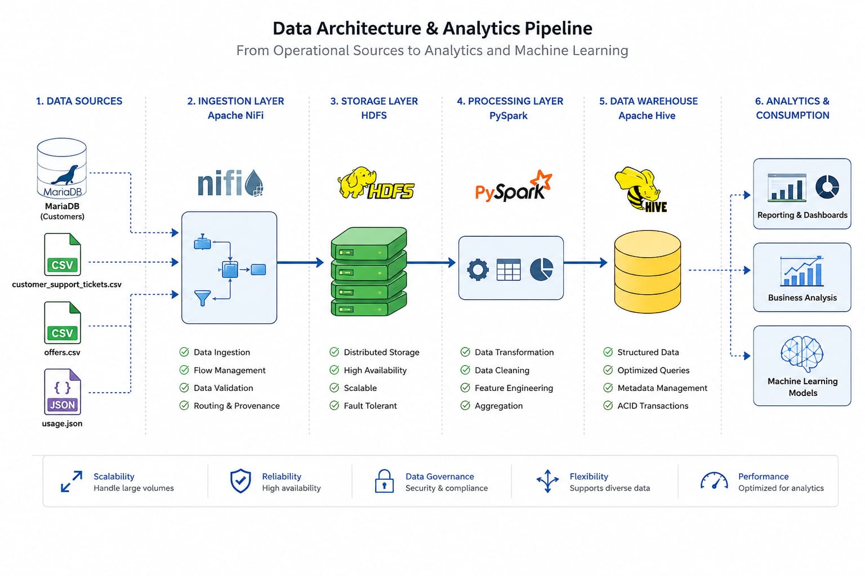

Data Ingestion Pipeline — Apache NiFi to HDFS
Apache NiFi is used as the data ingestion layer to collect data from both database and file-based sources and transfer it into HDFS. Two ingestion patterns are implemented:
- database ingestion for the customer data
- file ingestion for the remaining datasets.

1. MariaDB Customer Data
The customer data is stored in a MariaDB database. NiFi connects to MariaDB using the QueryDatabaseTable processor together with a configured DBCPConnectionPool Controller Service.
The connection is established by configuring the MariaDB JDBC driver, database URL, username, and password within the controller service. The QueryDatabaseTable processor then uses this connection to query the customer table and generate FlowFiles containing the retrieved records.
The resulting data passes through ConvertRecord to ensure the required record format before being written to HDFS using PutHDFS.
- Connection Target: Connects NiFi to the churn_src MariaDB database on localhost:3306.
- Driver & Library: Uses the org.mariadb.jdbc.Driver class with the driver JAR located at /usr/local/nifi/nifi-1.14.0/lib/mariadb-java-client-..
- Authentication: Authenticates using the root user account.
- Pool Limits: Caps total active and idle connections at 8 to manage database load.
- Timeout: Limits connection wait time to 500 ms before timing out.
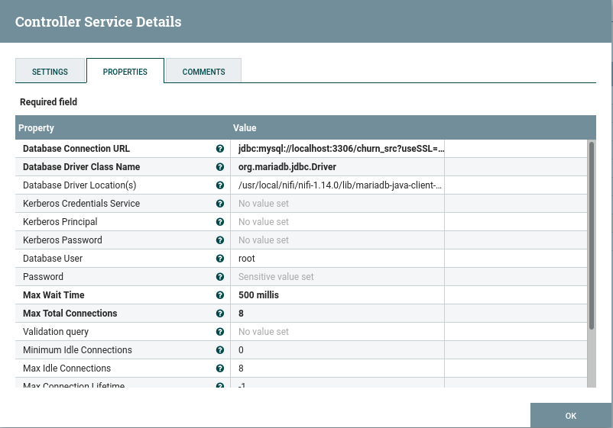
- Database Connection Pooling Service: DBCPConnectionPool ;Links the processor to the database connection pool defined earlier.
- Database Type: MySQL ;Specifies the SQL dialect used for query generation.
- Table Name: stg_customers ;Target source table to extract records from.
- Maximum-value Columns: customer_id Tracks the highest customer_id state across executions to ensure only new or updated records are incrementally ingested.
- Fetch Size: 1000 ;Retrieves 1,000 rows per JDBC network call to balance memory usage and extraction speed.
- Max Rows Per Flow File: 1000 ;Splits extracted data into chunks of 1,000 records per output FlowFile.
- Output Batch Size: 1 ;Emits 1 FlowFile per processor execution cycle.

QueryDatabaseTable processor
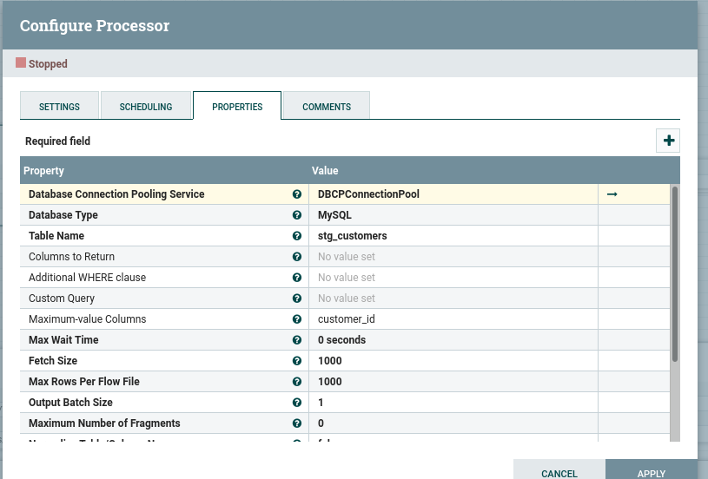

ConvertRecord Processor
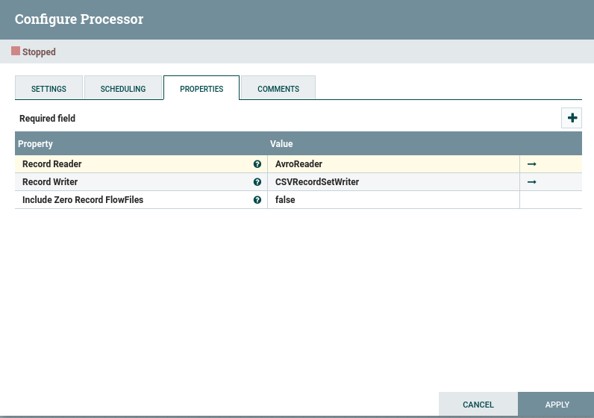
- Purpose: Converts binary Avro data from QueryDatabaseTable into plain CSV format before writing to HDFS.
- Record Reader (AvroReader): Reads incoming FlowFiles using the embedded Avro schema.
- Record Writer (CSVRecordSetWriter): Formats the parsed records into comma-separated text rows.
- Include Zero Record FlowFiles (false): Prevents creation of empty CSV files in HDFS when queries return 0 rows.
PutHDFS Processor
- Purpose: Writes output CSV files directly to the HDFS storage cluster.
- Hadoop Configuration Resources: Points to Hadoop configuration files (core-site.xml, hdfs-site.xml) to establish cluster connection settings.
- Directory (/churn_proj/customers): Specifies the destination path in HDFS where customer CSV files will be stored.
- Conflict Resolution Strategy (replace): Overwrites existing files of the same name in HDFS to maintain updated table data.
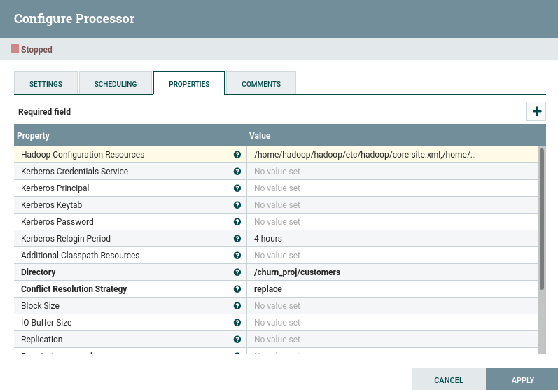
Pipeline flow:
MariaDB (customer table) → QueryDatabaseTable → ConvertRecord → PutHDFS → HDFS
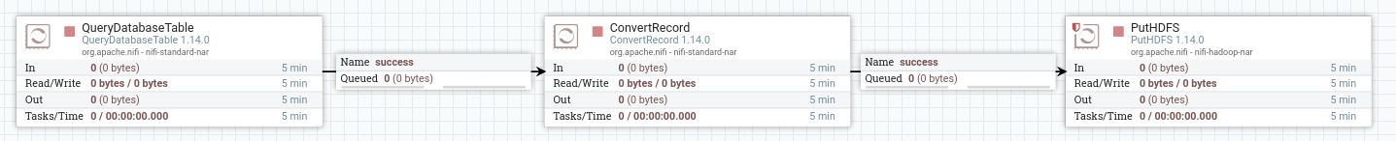
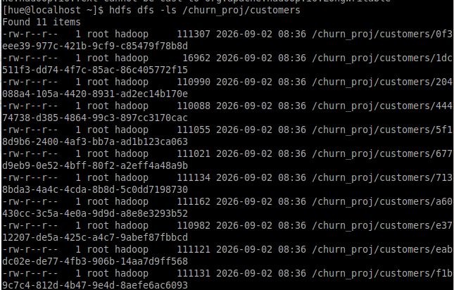
- Ingestion Status: 11 non-empty CSV files (~111 KB each) were successfully generated by NiFi and stored in /churn_proj/customers.
- File Permissions: All dataset files are owned by root:hadoop with standard -rw-r--r-- read/write access rights.
- Validation Command: Executed hdfs dfs -cat /churn_proj/customers/<file_id> | head -n 5 to inspect schema integrity and record formatting.
- Header Structure: Confirmed the presence of comma-delimited columns (e.g., customer_id, first_name, last_name, email, gender, churn_status).
- Verification Result: The output confirms valid CSV formatting, correct column headers, and successful incremental data landing in HDFS.
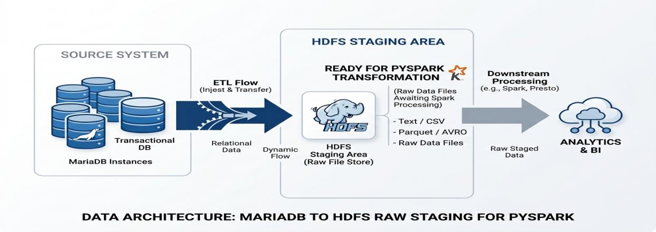
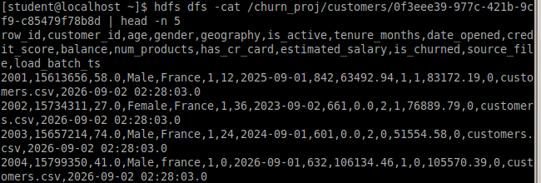

2. Other Files ingestion
A lightweight ingestion pipeline used to fetch raw file sources from the local filesystem and store them directly into HDFS.
Processed Datasets
- CSV Datasets: customer_support_tickets.csv, offers.csv
- JSON Dataset: usage.json
Component Summary
- GetFile: Polls a specified local directory to ingest raw CSV and JSON files into NiFi FlowFiles upon detection.
- PutHDFS: Writes the ingested files directly into their designated target directories on the HDFS cluster.

GetFile Processor
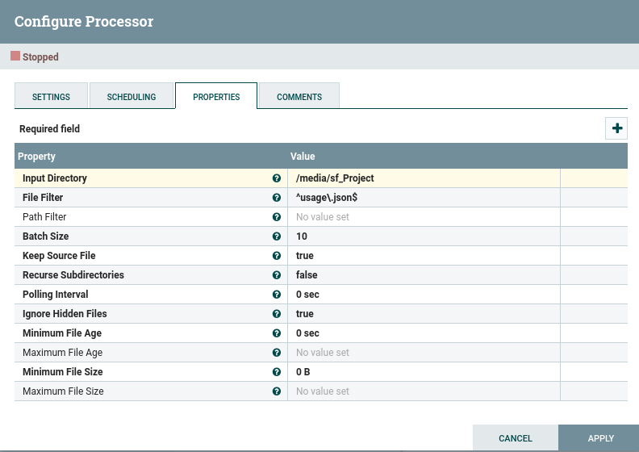
- Input Directory (/media/sf_Project): Specifies the shared local directory where the raw source files are picked up.
- File Filter: Uses regular expressions to target and ingest specific files individually:
- ^usage\.json$ (for the JSON file)
- ^customer_support_tickets\.csv$ (for the tickets CSV file)
- ^offers\.csv$ (for the offers CSV file)
- Keep Source File (true): Retains the original raw files in the source directory after ingestion instead of deleting.
- Batch Size (10): Limits processing to a maximum of 10 files per execution cycle.
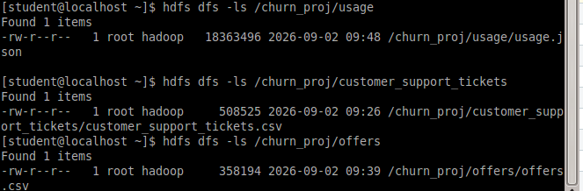
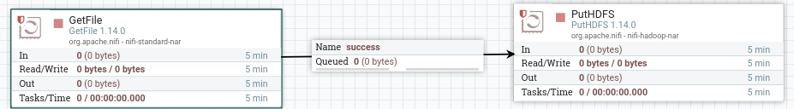


2. PySpark Data Processing Pipeline (Medallion Architecture)
The PySpark ETL pipeline executes on a distributed cluster to process raw data landed in HDFS through Bronze, Silver, and Gold transformation stages.
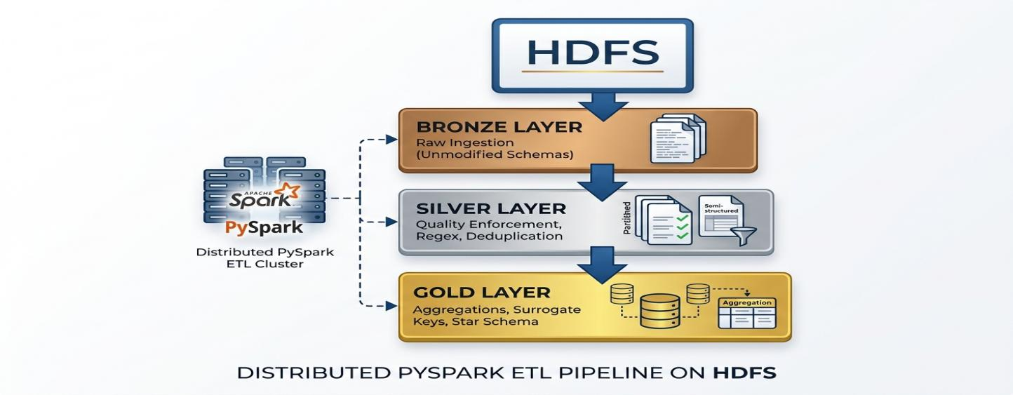

2.1 Bronze Layer (Raw Ingestion)
The Bronze layer contains the raw, uncleaned data as received from the source files. At this stage, the data is loaded into PySpark DataFrames without applying any cleaning or transformation operations.
For each of the four source tables, the schema is printed to display the available features and their original data types. The number of rows is also calculated and reported to provide an initial overview of the raw datasets.
No data cleaning, type conversion, or feature modification is performed in the Bronze layer. The purpose of this layer is to preserve and inspect the data in its original form before applying transformations in the subsequent layers.
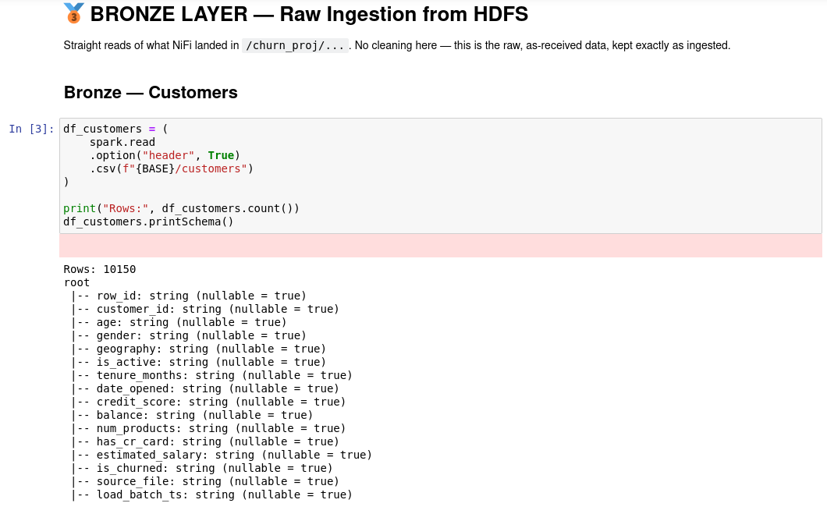

2.2 Silver Layer (Cleaning and Transformation)
The Silver layer is the cleaning and conformance layer between raw Bronze data and the downstream warehouse/Gold layer.
The processing implemented in the notebook performs:
- Data-type standardization
- Whitespace trimming
- Sentinel-value normalization
- Categorical-value standardization
- Domain validation
- Duplicate detection and removal
- Referential-integrity checks against customer_id
- Missing-value analysis
- Missing-value imputation
- Final schema and NULL validation

Silver — Customer Features

2.1 Source
The Bronze customer source initially contained 10,150 rows, with all business columns represented as strings.
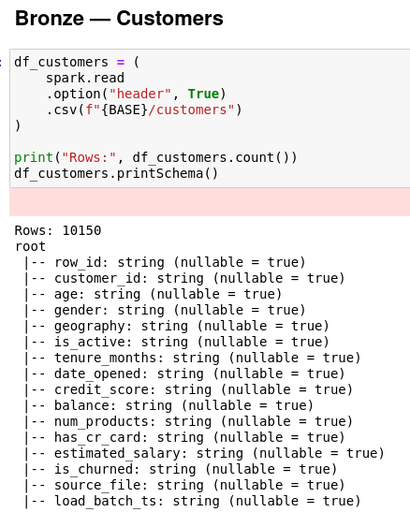2.2 General preprocessing

Initial problem
The notebook explicitly notes that the customer features initially had string data types, even for numeric, Boolean, date, and timestamp attributes.

row_id Removed
row_id was treated as a technical identifier rather than a business attribute and was removed from the customer dataset.
Reason: It does not represent a meaningful customer business attribute and is unnecessary in the cleaned customer dataset.

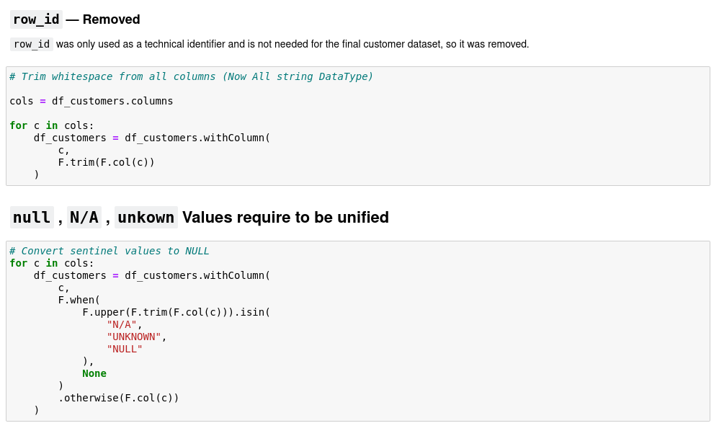

White space
White space was trimmed from all customer columns before further processing.
Transformation: TRIM(column)
Purpose: Prevent values such as " France " or " Male " from being treated as different values from "France" or "Male".

Sentinel values
The notebook identifies N/A, UNKNOWN, and NULL string representations and converts them into actual database NULL values.
This provides a consistent representation of missing/unknown data.

3. Customer Feature-by-Feature preprocessing

customer_id
Role: Customer business identifier.
Silver transformation: No value transformation is documented for customer_id.
Validation: It is retained as a string and subsequently used as the reference key for validating Offers and Tickets.

age

Problems found
The source contained:
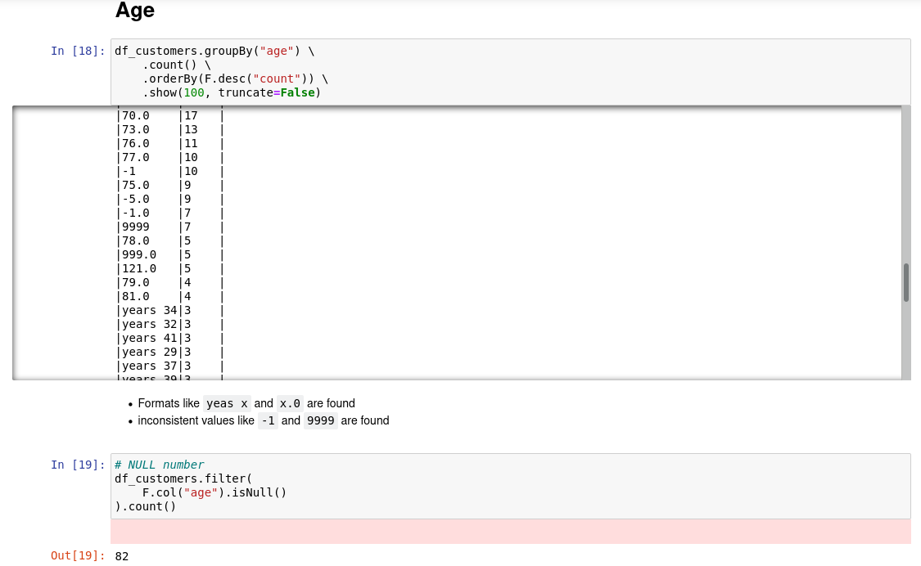
- normal numeric values such as 25, 37, 58
- values represented as 37.0
- textual values such as "years 42"
- invalid values such as -1, -5
- extreme values such as 999, 9999, 121, 150
- NULLs
The EDA identified 82 NULLs initially.

Transformation
The notebook extracts the numeric portion:
"years 42" → 42
"25" → 25
and converts the result to INTEGER.
Then domain validation is applied: age < 15 OR age > 100 → NULL
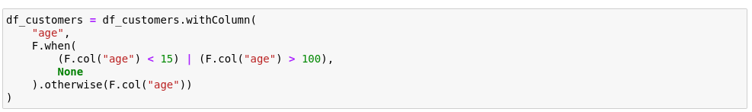
This converted clearly invalid ages into NULL. After this validation, the NULL count became 128.
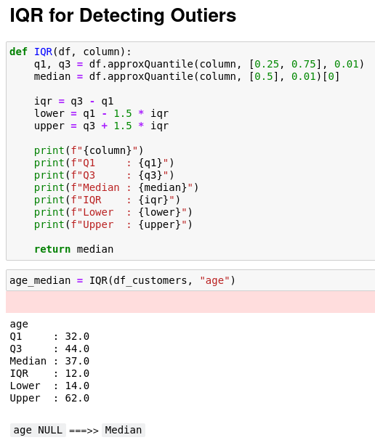
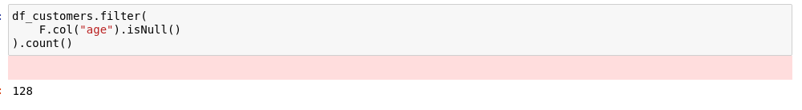

Missing-value treatment
An IQR analysis produced:
- Q1 = 32
- Q3 = 44
- Median = 37
- Lower bound = 14
- Upper bound = 62
The NULL ages were subsequently filled using the median 37.

Final
age → INTEGER
invalid/missing age → median 37

gender

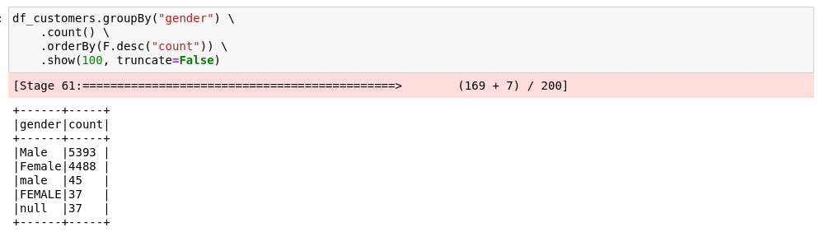
Problems found
The source contained:
- Male
- Female
- male
- FEMALE
- NULL
The EDA showed:
Value | Count
Male | 5,393
Female | 4,488
male | 45
NULL | 37
FEMALE | 37

Transformation
Values are standardized:
MALE / M → Male
FEMALE / F → Female
The implemented transformation normalizes the values using uppercase comparisons.

Missing-value treatment
The mode was calculated as: Male
NULL gender values were filled with the mode.

Final
gender → Male / Female
NULL → Male
The final Silver schema marks gender as non-nullable.

Geography

Problems found
The source contained:
- France
- Germany
- Spain
- france
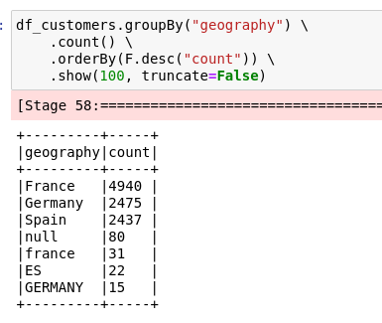
- GERMANY
- ES
- NULL
EDA showed the inconsistent representations.

Transformation
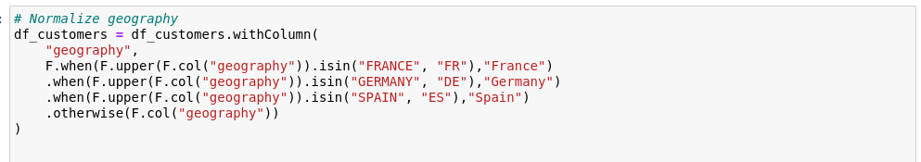
The notebook maps:
FRANCE / FR → France
GERMANY / DE → Germany
SPAIN / ES → Spain

Missing-value treatment
The mode was: France
NULL geography values were replaced with France.

Final
geography → France / Germany / Spain
NULL → France

is_active and is_churned

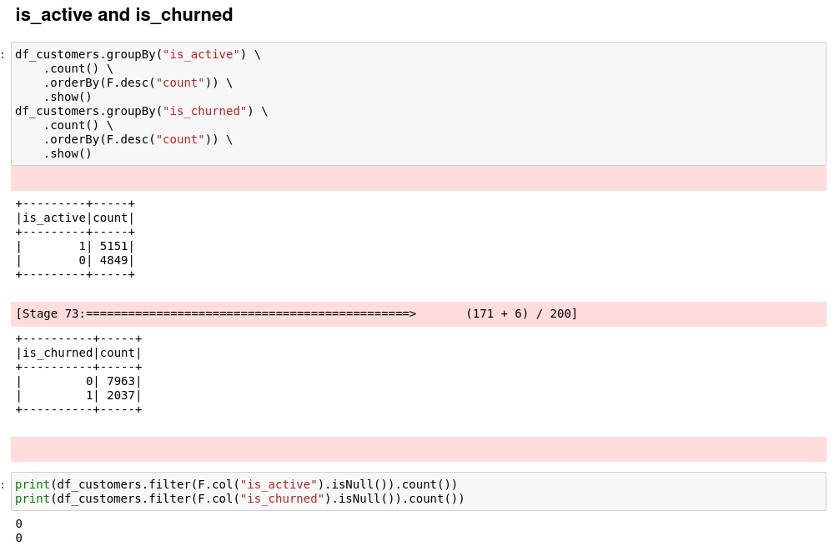
Problems found
The source values were: 0 & 1
with:
- 5,151 active
- 4,849 inactive
- 0 NULLs

Transformation
Converted from string/integer representation into Boolean:
1 → True && 0 → False

Final : is_active & is_churned → BOOLEAN

date_opened

Problems found
The column contained many different date representations, including:
2026-06-13
04/03/2026
07-03-2026
May 31, 2026
2026/06/13
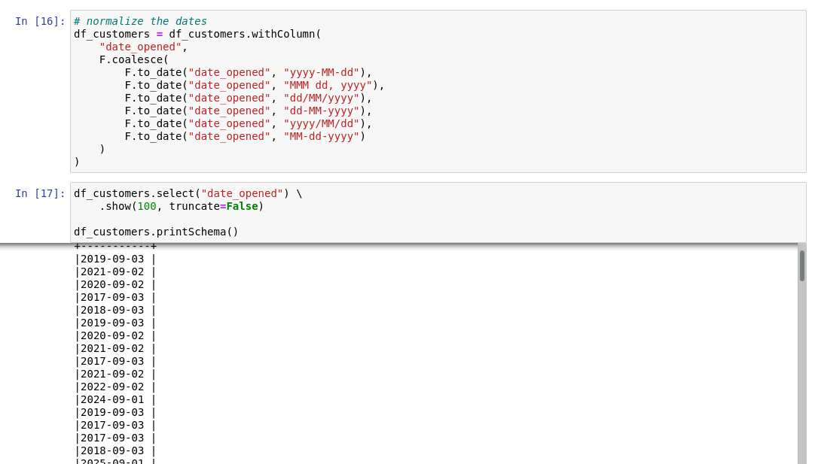
There were initially 0 NULL dates.

Transformation
Multiple formats are attempted using coalesce:
yyyy-MM-dd
MMM dd, yyyy
dd/MM/yyyy
dd-MM-yyyy
yyyy/MM/dd
MM-dd-yyyy

Final

date_opened → DATE
This standardizes all valid representations to a single Spark DATE type.

tenure_months

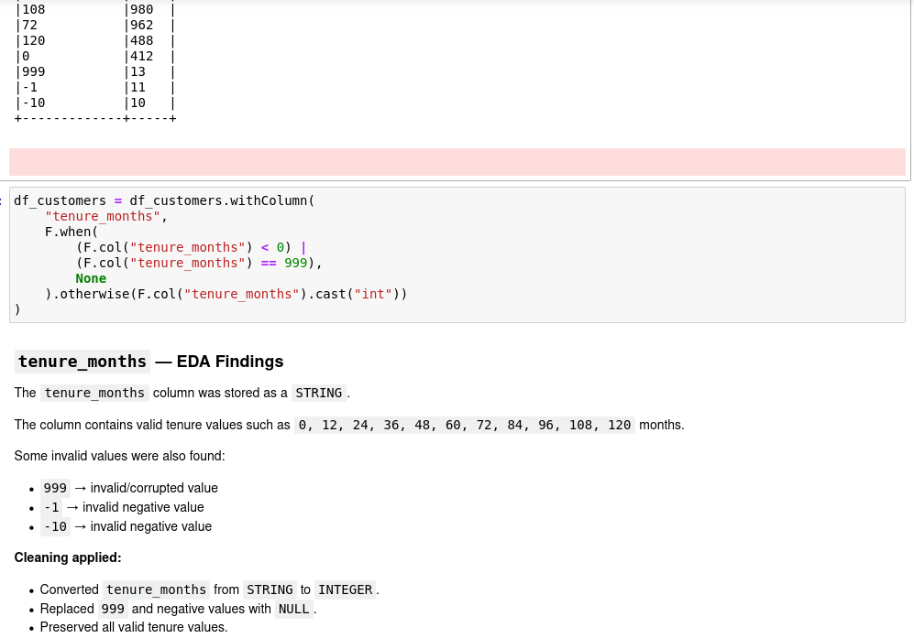
Problems found
Valid values include:
0, 12, 24, 36, 48, 60,
72, 84, 96, 108, 120
Invalid values include:
999
-1
-10

Transformation
negative values → NULL
999 → NULL
otherwise → INTEGER

Final
tenure_months → INTEGER
Valid tenure values are preserved.

credit_score

Problems found
Most values were numeric, but corrupted representations were found:
"six hundred"
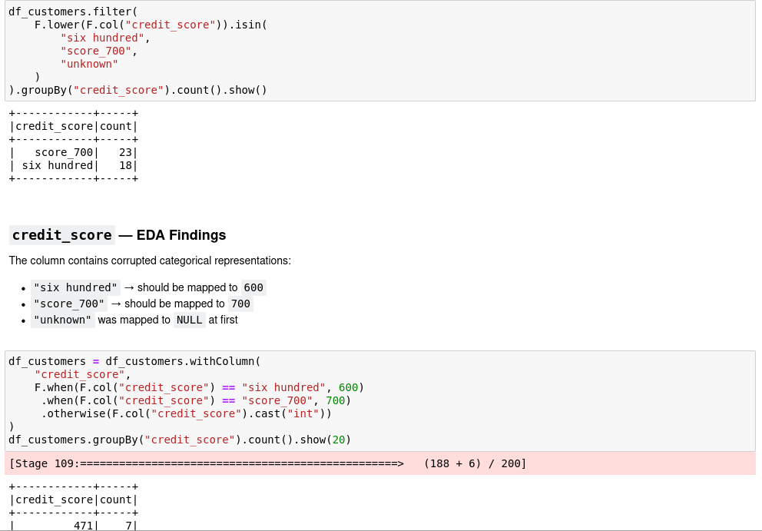
"score_700"
"unknown"

Transformation
"six hundred" → 600
"score_700" → 700
and the remaining values are cast to integer.

Missing-value treatment
IQR analysis:
- Q1 = 582
- Q3 = 715
- Median = 650
- Lower bound = 382.5
- Upper bound = 914.5
Missing credit scores were filled with 650.

Final
credit_score → INTEGER
NULL → 650

balance

Problems found
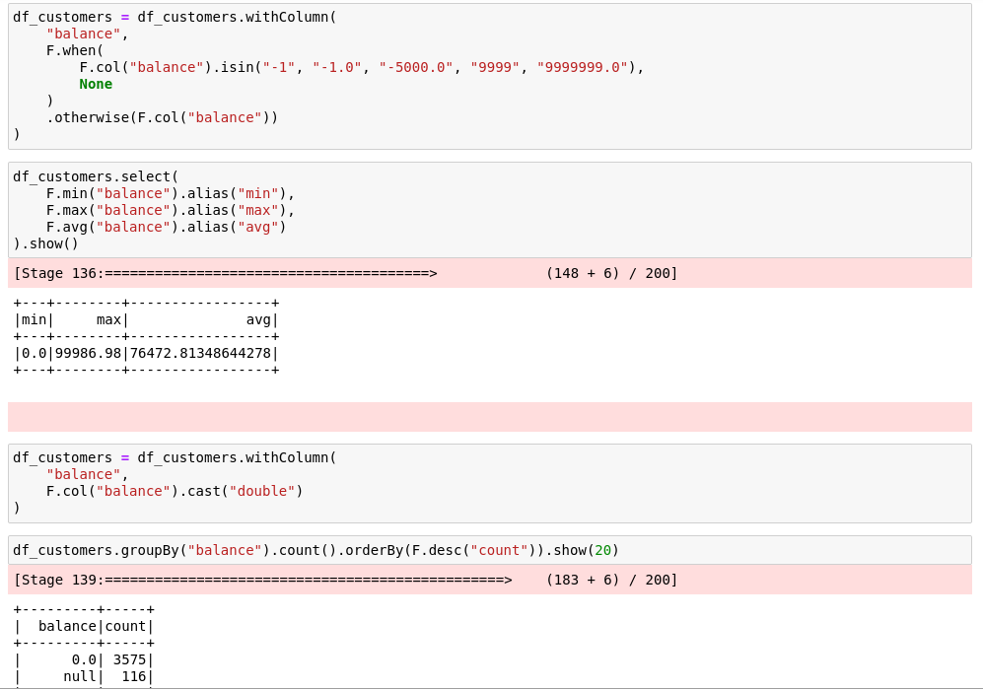
The EDA identified:
- 0.0 → valid
- NULL → missing
- -1, -1.0 → invalid sentinel
- -5000.0 → invalid/suspicious
- 9999 → suspicious
- 9999999.0 → extreme suspicious value

Transformation
The following values were converted to NULL:
-1
-1.0
-5000.0
9999
9999999.0
Then the column was cast to: DOUBLE
After cleaning the range was:
min = 0
max = 99,986.98
avg ≈ 76,472.81

Missing-value treatment
Median was calculated as approximately 96,402.96, and NULL balances were replaced by the median.

Final
balance → DOUBLE
NULL/invalid → median

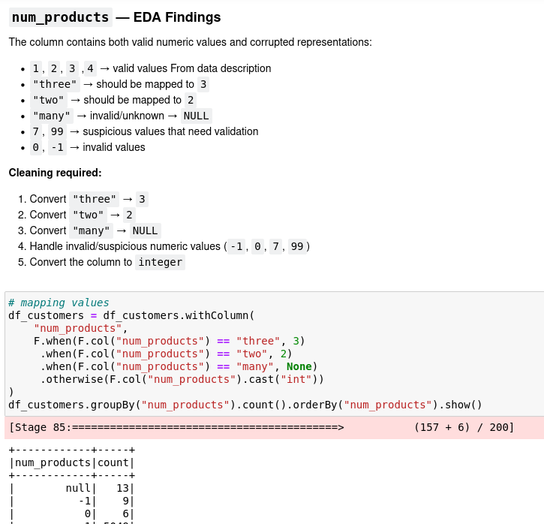
num_products

Problems found
Valid values: 1, 2, 3, 4
Corrupted/suspicious values:
"three" "two" "many" -1 0 7 99

Transformation
"three" → 3
"two" → 2
"many" → NULL
Then values are converted to integers.
Domain validation then applies:
value < 1 OR value > 4 → NULL
After validation:
Value | Count
1 | 5,049
2 | 4,567
3 | 283
4 | 60
NULL | 41

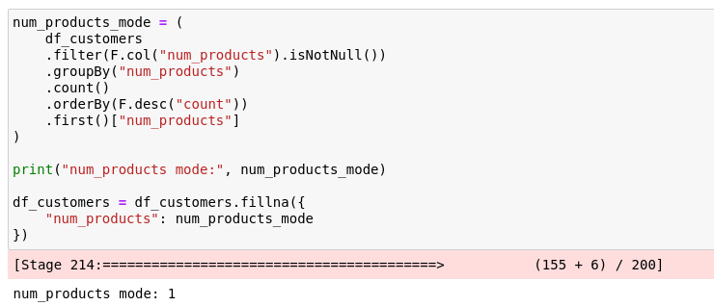
Missing-value treatment
The mode was 1, and missing values were filled with 1.

Final
num_products → INTEGER
invalid → NULL → mode 1

has_cr_card

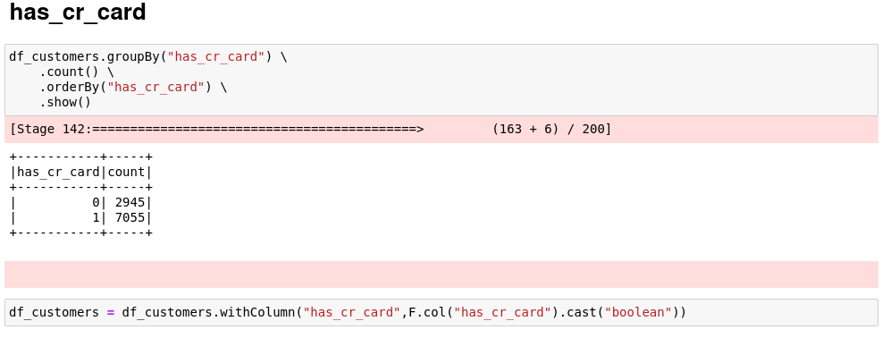
Source
Values were:
0 → 2,945
1 → 7,055
with no NULL values shown.

Transformation
Converted to Boolean.
0 → False
1 → True

Final
has_cr_card → BOOLEAN

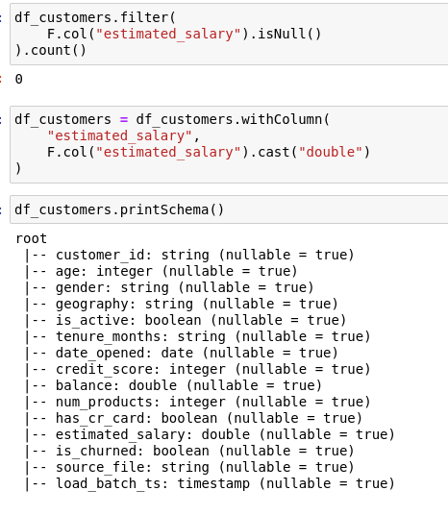
estimated_salary

EDA
The notebook checks the distribution and confirms 0 NULL values.

Transformation
Converted from string to => DOUBLE

Final
estimated_salary → DOUBLE
No imputation was required.

4. Customer Duplicate Handling
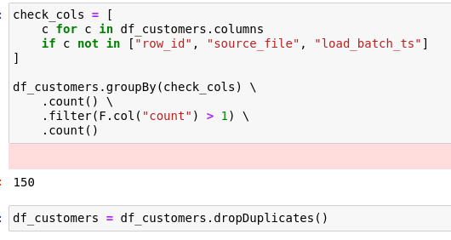
We found 150 duplicate groups based on the business/customer attributes.
The dataset was then deduplicated using: dropDuplicates()

Result : Duplicate customer records were removed before the downstream Silver output.

5. Customer Missing-Value Strategy
The final customer imputation strategy is:
Feature | Missing-value treatment
gender | Mode = Male
geography | Mode = France
age | Median = 37
credit_score | Median = 650
balance | Median ≈ 96,402.96
num_products | Mode = 1

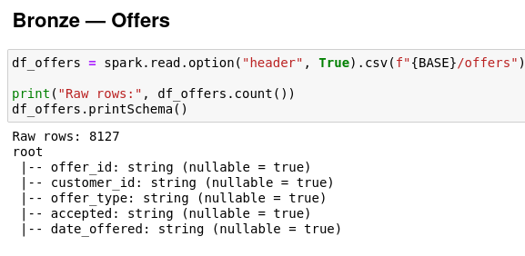
Silver — Offers
The Offers source contains the following columns:
- offer_id
- customer_id
- offer_type
- accepted
- date_offered
The Bronze dataset contained 8,127 records.

offer_id
Role: Offer identifier.
No value transformation is applied to the offer_id itself.

Duplicate Handling
The notebook identified 107 duplicate offer_id groups.
Duplicate offers were removed using the following operation:
dropDuplicates(["offer_id"])
NULL offer_id values were not removed by this operation and were explicitly preserved during the validation process.

customer_id
The Offer customer_id was validated against the cleaned Customer dataset.
The notebook performed a left-anti join to identify customer IDs that do not exist in the Customer dataset.
The validation identified 144 orphan customer_id rows.
These orphan records were then removed using a left_semi join against the valid customer IDs.

Result
Only Offer records whose customer_id exists in the cleaned Customer dataset remain in the Silver layer.

offer_type

Problems Identified
The source contained the following expected offer types:
- Fee Waiver
- Cashback
- Loyalty Bonus
- Product Upgrade
- Rate Discount
Several casing inconsistencies were also found, including:
- fee waiver
- cashback
- product upgrade
- RATE DISCOUNT
The dataset also contained missing or sentinel representations such as:
- Unknown
- N/A
- NULL
- actual NULL

Transformation
The casing of the offer types was standardized:
- fee waiver → Fee Waiver
- cashback → Cashback
- product upgrade → Product Upgrade
- rate discount → Rate Discount
The values Unknown, N/A, and string representations of NULL were converted into actual NULL values.

Imputation
After standardization, there were 78 NULL values in offer_type.
These missing values were replaced with:
Unknown
Therefore, the final Silver dataset does not contain missing offer_type values.

accepted

Problems Identified
The source contained several different representations of acceptance status:
- True
- False
- TRUE
- TRUEE
- 1
- 0
- yes
- no
- MAYBE
- 2
- NULL

Transformation
Values representing an accepted offer were standardized as follows:
- TRUE → True
- TRUEE → True
- 1 → True
- YES → True
Values representing a rejected offer were standardized as follows:
- FALSE → False
- 0 → False
- NO → False
Any other value that could not be reliably interpreted as accepted or rejected was converted to NULL.

Important Design Decision
The notebook does not convert unknown acceptance values into False.
Instead, the original accepted column remains a nullable Boolean field:
accepted → BOOLEAN (nullable)
A separate accepted_flag field is also created to provide a user-friendly categorical representation:
- True → Yes
- False → No
- NULL → Unknown
This approach prevents unknown acceptance statuses from being incorrectly interpreted as rejected offers.

date_offered

Problems Identified
Multiple date formats were found in the source data, including:
- yyyy-MM-dd
- MM-dd-yyyy
- yyyy/MM/dd
- dd/MM/yyyy
- dd-MM-yyyy
- MMM dd, yyyy

Transformation
The different supported date formats were parsed and standardized into the Spark DATE data type.
Therefore:
date_offered → DATE

Missing Values
There were 64 NULL values in date_offered.
The original date_offered column remains nullable because a missing business date should not be replaced with a fabricated real-world date.
A separate field called:
date_offered_key
is created for downstream date-dimension processing.
For missing dates:
NULL → 1900-01-01
The value 1900-01-01 is used as a technical/default date key so that records with missing offer dates can still be joined cleanly to the Date dimension without claiming that the offer actually occurred on that date.

7. Silver — Tickets
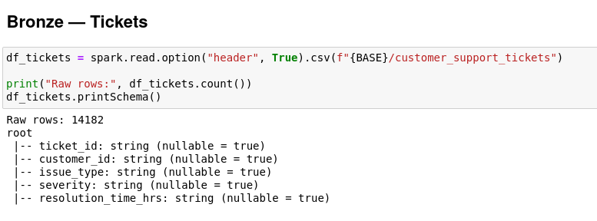
The Ticket source contains the following columns:
- ticket_id
- customer_id
- issue_type
- severity
- resolution_time_hrs
The source contains 14,182 raw records.

ticket_id
Role: Ticket identifier.
No transformation is applied to the identifier itself.
Duplicate records were checked across the complete record. The notebook found 210 duplicate groups, and exact duplicate records were removed.

customer_id
Ticket customer IDs were checked against the valid customers in the cleaned Customer dataset.
The notebook found 209 non-null orphan customer IDs.
These orphan records were removed using a left_semi join against the valid customer IDs.

Final Validation
After the cleaning process: customer_id NULLs = 0
This ensures that every remaining ticket is associated with a valid customer.

issue_type

Problems Identified
The expected issue types are:
- App Bug
- Loan Query
- Billing
- Fraud Alert
- Card Problem
- Login Issue
Several inconsistent representations were found, including:
- login issue
- app bug
- loan query
- billing
- FRAUD ALERT
- CARD PROBLEM
The dataset also contained missing-value representations such as:
- Unknown
- N/A
- NULL
- actual NULL

Transformation
The different casing representations were standardized to the expected values:
- app bug → App Bug
- loan query → Loan Query
- billing → Billing
- fraud alert → Fraud Alert
- card problem → Card Problem
- login issue → Login Issue
The values Unknown, N/A, and string representations of NULL were converted to actual NULL values.

Imputation
After standardization, the NULL values were handled using the most frequent value (mode).
The calculated mode was:
Loan Query
Therefore, missing issue_type values were replaced with Loan Query.

severity

Problems Identified
The expected severity values are:
- Low
- Medium
- High
- Critical
Inconsistent representations were also found, including:
- low
- MEDIUM
- high
- CRITICAL
The dataset also contained missing-value representations such as:
- Unknown
- N/A
- NULL

Transformation
All valid severity values were standardized to the following format:
- Low
- Medium
- High
- Critical
The values Unknown, N/A, and string representations of NULL were converted to actual NULL values.

Imputation
The most frequent severity value (mode) was: Low
Therefore, missing severity values were replaced with Low.

resolution_time_hrs

Problems Identified
The source contained:
- Valid decimal resolution times
- NULL values
- Negative values such as -1 and -5
- Sentinel values such as 999, 9999, and 2500

Transformation
The original field was stored as a string and was converted to a numeric data type.
STRING → DOUBLE
Invalid and sentinel values were converted to NULL:
- Negative values → NULL
- 999 → NULL
- 9999 → NULL
- 2500 → NULL
After the cleaning process, the observed range was:
- Minimum = 1.0
- Maximum = 119.9
- NULL values = 449

Imputation
An IQR-based analysis was performed to determine the appropriate value for missing resolution times.
The calculated statistics were:
- Q1 = 2.4
- Q3 = 15.3
- Median = 6.5
- IQR = 12.9
The 449 missing values were replaced with the median value:
6.5 hours

Final State
- resolution_time_hrs → DOUBLE
- NULL values → 6.5

8. Silver — Usage
The Usage dataset contains 120,000 records.
The dataset contains the following columns:
- customer_id
- log_date
- monthly_balance
- num_products
- product_type
- usage_log_id

Missing Values
A complete NULL audit was performed across all Usage columns.
The result was:
0 NULL values
Therefore, no missing-value imputation or record removal was required for the Usage dataset.
This is different from the Customers, Offers, and Tickets datasets, where missing and invalid values required additional treatment.

Silver Treatment
Based on the Silver-layer implementation in the notebook, the Usage dataset was validated for completeness, but no additional detailed cleaning or type-conformance transformations were implemented.
The existing data types remain:
Column | Data Type
customer_id | LONG
log_date | STRING
monthly_balance | DOUBLE
num_products | LONG
product_type | STRING
usage_log_id | LONG
Therefore, the Usage Silver-layer treatment can be summarized as:
Validated for completeness, with no NULL remediation required. Existing data types were retained in the current notebook implementation.

Gold Layer - Data Warehouse Architecture (Apache Hive)
This section describes the technical implementation of the Gold Layer within the Medallion Data Architecture. The primary objective is to transform cleansed, columnar data from the Silver Layer into a business-ready Star Schema optimized for Business Intelligence (BI) and analytical workloads. The pipeline was implemented using Apache Hive within the Hadoop ecosystem.
2. Environment & Session Configurations
To ensure stable execution and allow for advanced table partitioning within Hive, specific session parameters and execution engines were configured before running the ETL jobs.
SQL
-- Enable dynamic partitioning for the Fact table
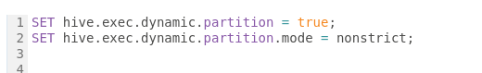
3. Data Definition Language (DDL) - Star Schema Design
The data model was structured into one partitioned Fact table and multiple Dimension tables. All tables were created as EXTERNAL tables stored in PARQUET format to decouple compute from storage and optimize read performance.
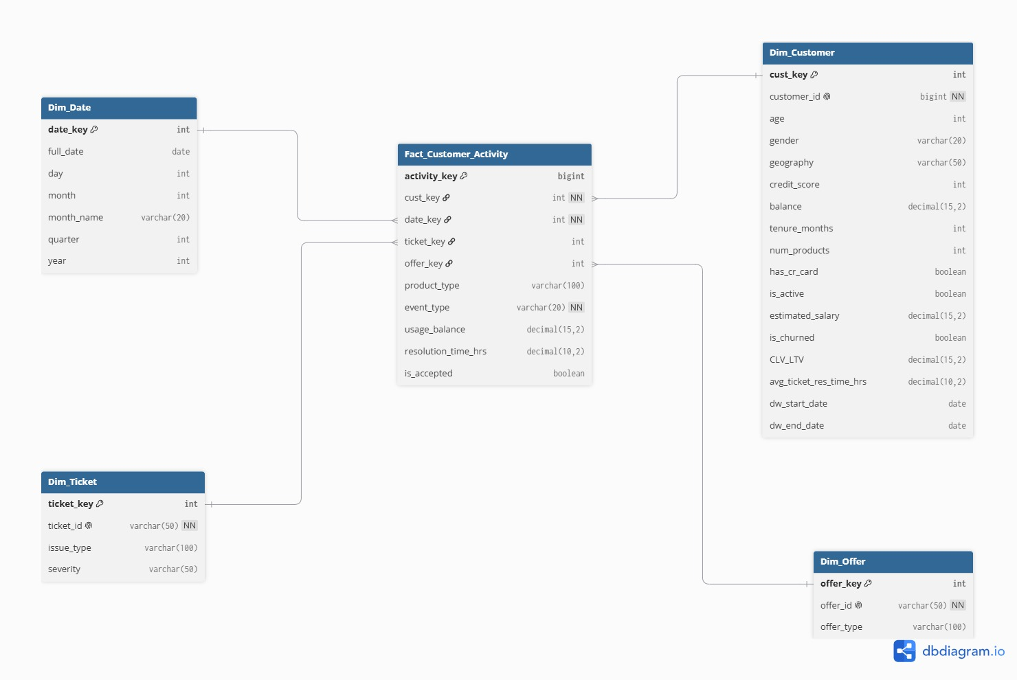
SQL
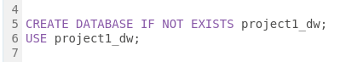
-- ==========================================
-- Dimension Tables
-- ==========================================

-- 1. Dim_Customer

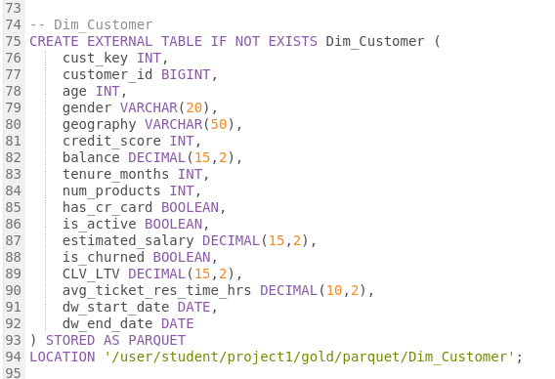
-- 1. Dim_Product
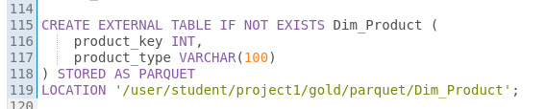
-- 2. Dim_Offer
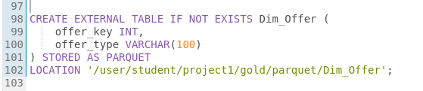
-- 3. Dim_Ticket
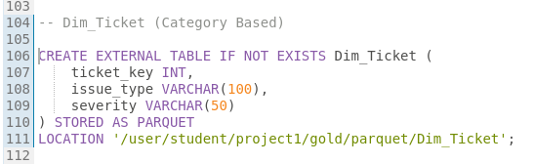
-- 4. Dim_Date
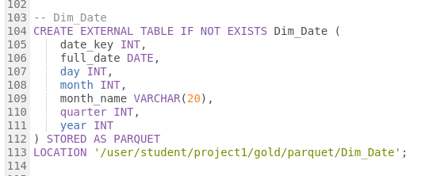
-- 5. Fact_Customer_Activity (Dynamic Partitioning)
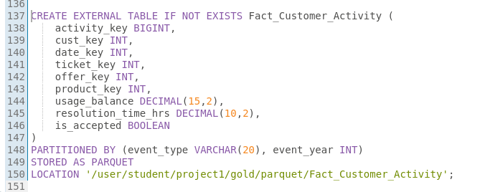

4. Data Manipulation Language (DML) - ETL Processing
The ETL process involved complex transformations, including the programmatic calculation of Customer Lifetime Value (CLV/LTV), hashing for surrogate key generation (ABS(HASH())), and handling orphan records using sentinel values (e.g., -1).
SQL
-- ==========================================
-- Loading Dimensions
-- ==========================================

-- Load Dim_Customer (with programmatic CLV_LTV calculation)
WITH Customer_Ticket_Avg AS (
SELECT customer_id, AVG(resolution_time_hrs) AS avg_res
FROM tickets
GROUP BY customer_id
)
INSERT OVERWRITE TABLE Dim_Customer
SELECT
ABS(HASH(c.customer_id)) AS cust_key,
CAST(c.customer_id AS BIGINT),
c.age, c.gender, c.geography, c.credit_score,
CAST(c.balance AS DECIMAL(15,2)), c.tenure_months, c.num_products,
c.has_cr_card, c.is_active, CAST(c.estimated_salary AS DECIMAL(15,2)), c.is_churned,

-- CLV / LTV Logic
CAST(
CASE
WHEN c.is_churned = TRUE THEN 0
ELSE c.balance * c.num_products * (
CASE
WHEN c.tenure_months < 12 THEN 5
WHEN c.tenure_months < 36 THEN 4
WHEN c.tenure_months < 60 THEN 3
ELSE 2
END
)
END AS DECIMAL(15,2)
) AS CLV_LTV,

CAST(t.avg_res AS DECIMAL(10,2)) AS avg_ticket_res_time_hrs,
c.date_opened AS dw_start_date,
NULL AS dw_end_date
FROM customers c
LEFT JOIN Customer_Ticket_Avg t ON c.customer_id = t.customer_id;

-- Load Dim_Offer
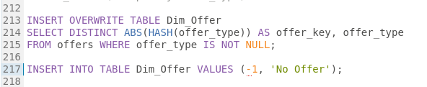
-- Load Dim_Ticket
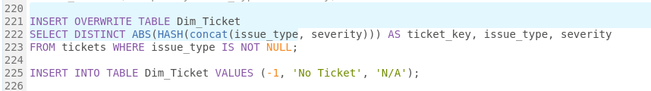
-- Load Dim_Product

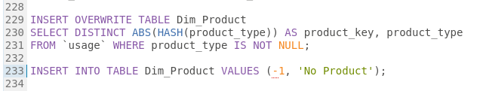
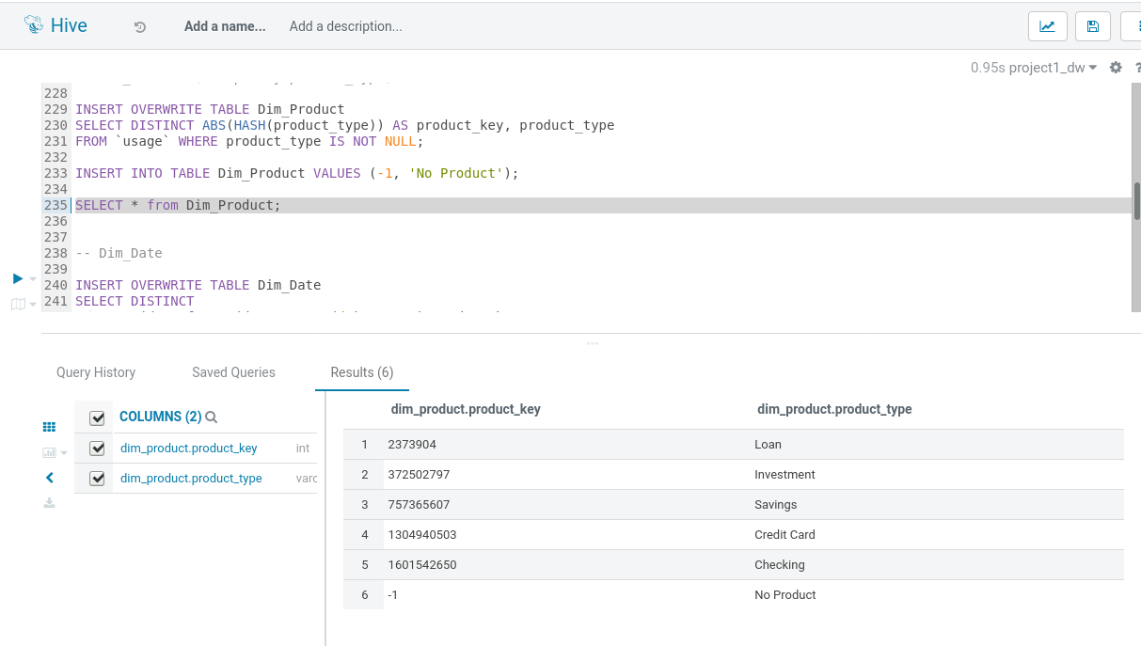
-- Load Dim_Date
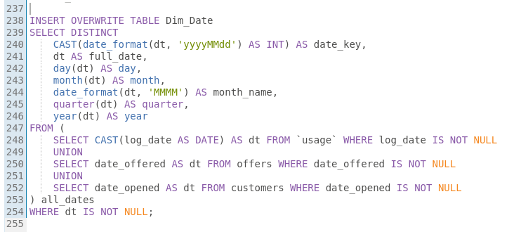
-- ==========================================
-- Loading Fact Table
-- ==========================================

INSERT OVERWRITE TABLE Fact_Customer_Activity PARTITION(event_type, event_year)
-- 1. Usage Events
SELECT
CAST(ABS(HASH(usage_log_id)) AS BIGINT) AS activity_key,
ABS(HASH(customer_id)) AS cust_key,
CAST(date_format(CAST(log_date AS DATE), 'yyyyMMdd') AS INT) AS date_key,
-1 AS ticket_key, -1 AS offer_key, product_type,
CAST(monthly_balance AS DECIMAL(15,2)) AS usage_balance,
NULL AS resolution_time_hrs, NULL AS is_accepted,
'Usage' AS event_type, year(CAST(log_date AS DATE)) AS event_year
FROM `usage`
UNION ALL
-- 2. Offer Events
SELECT
CAST(ABS(HASH(concat(customer_id, offer_id))) AS BIGINT) AS activity_key,
ABS(HASH(customer_id)) AS cust_key,
CAST(date_format(date_offered, 'yyyyMMdd') AS INT) AS date_key,
-1 AS ticket_key, ABS(HASH(offer_id)) AS offer_key, 'N/A' AS product_type,
NULL AS usage_balance, NULL AS resolution_time_hrs, accepted AS is_accepted,
'Offer' AS event_type, year(date_offered) AS event_year
FROM offers
UNION ALL
-- 3. Support Ticket Events
SELECT
CAST(ABS(HASH(ticket_id)) AS BIGINT) AS activity_key,
ABS(HASH(customer_id)) AS cust_key, -1 AS date_key,
ABS(HASH(ticket_id)) AS ticket_key, -1 AS offer_key, 'N/A' AS product_type,
NULL AS usage_balance, CAST(resolution_time_hrs AS DECIMAL(10,2)), NULL AS is_accepted,
'Support_Ticket' AS event_type, 1900 AS event_year
FROM tickets;
6. Data Extraction for BI Consumption
Finally, the analytical datasets were exported from Hive to the Hadoop Distributed File System (HDFS), and subsequently merged into flat .csv files on the local Linux file system for seamless ingestion into Power BI / Tableau.
Exporting Data from Hive to HDFS
SQL
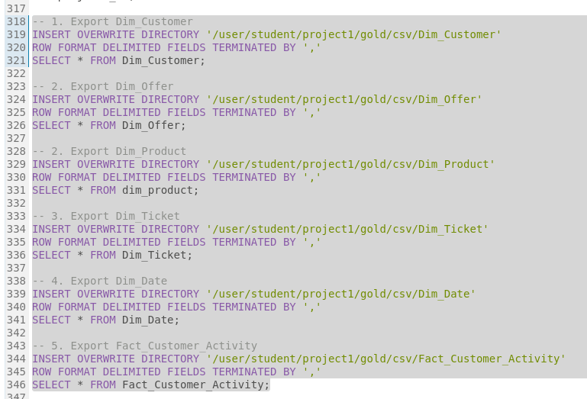

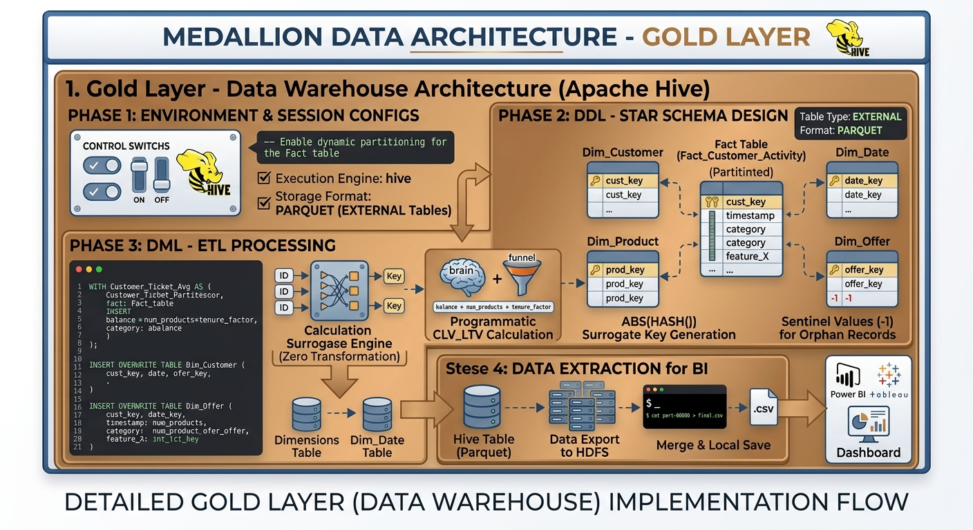

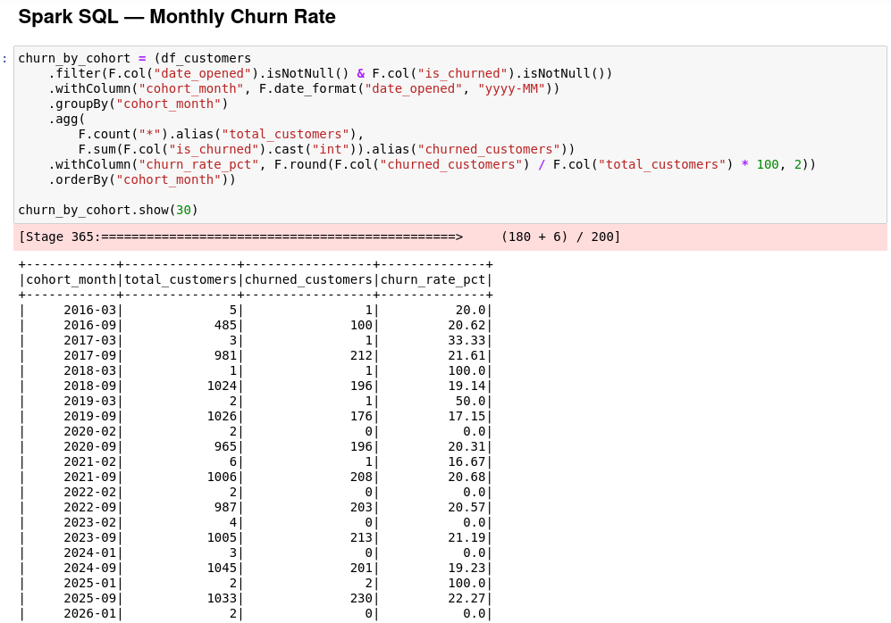

Cohort Churn Rate by Signup Month
Target of this calculation: for each signup month (date_opened), what percentage of customers who opened their account that month are currently marked as churned (is_churned = 1). This is a cohort snapshot, not a time-series churn rate — it doesn't show churn happening in a given month, only the churn status today of everyone who joined in that month. True monthly churn (customers who left during that specific month) would need a churn-event date, which doesn't exist in this data.
What the output presents: one row per signup month, with total_customers in that cohort, how many of them are churned_customers, and the resulting churn_rate_pct.

Executive Customer Churn & Revenue Risk Dashboard: Technical & Business Report
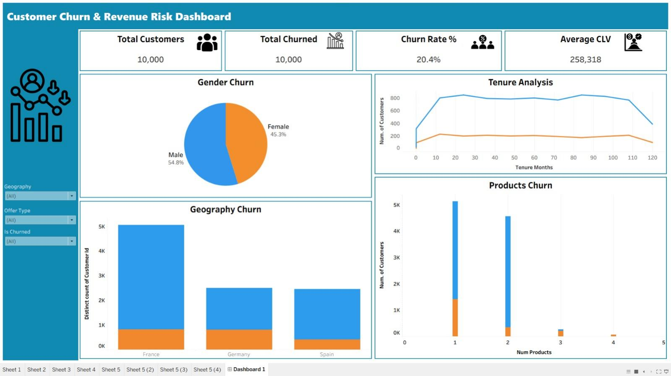

Strategic Objective & Business Value
Designed and implemented an executive-level analytics solution tailored for engineering and product leadership to proactively monitor customer attrition, quantify revenue exposure, and evaluate Customer Lifetime Value (CLV). The system transforms raw customer data into actionable business insights, connecting operational risk metrics with financial outcomes.

UI/UX Architecture & Layout System
Executive Navigation Panel: Implemented a fixed-width sidebar containing global interactive controls and brand identifiers, providing a consistent and cohesive enterprise-style interface.
Top KPI Tier: Positioned a horizontal KPI section at the top of the dashboard displaying four core indicators—Total Customers (10,000), Total Churned (2,037), Churn Rate (20.4%), and Average CLV (258,318)—providing an immediate overview of overall customer and business health.
Structured 2×2 Analytical Grid: Organized the main analytical visualizations into a balanced four-quadrant layout to analyze demographic vulnerability, geographic patterns, customer retention milestones, and product adoption behavior.

Visual Structure & Aesthetic Design
Minimalist Presentation: Removed default chart grid lines to reduce visual clutter and improve data readability, keeping the focus on key trends and insights.
Clean UI Formatting: Applied structured container backgrounds and transparent header elements to achieve a clean, modern, and professional executive dashboard design.

Interactivity & Data Integration
Synchronized Global Filtering: Configured multi-variable, cross-source filters—including Is Churned, Gender, Geography, and Products—to work consistently across all connected dashboard views.
Real-Time Root-Cause Analysis: Enabled dynamic updates across multiple analytical views, allowing stakeholders to drill down into specific behavioral, demographic, and geographic segments to investigate potential drivers of customer churn.

5.Model Layer — Churn Prediction (LinearSVC)

1. Data Source
The model was trained directly from Dim_Customer.csv, a headerless export generated from the Gold Layer.
- Source: /media/sf_Project/Dim_Customer.csv
- HDFS location: hdfs:///churn_proj/dim_customer_csv/
- Records loaded: 10,000
Since the CSV file did not contain a header, column names and data types were explicitly defined during PySpark ingestion.

2. Preprocessing Audit

Missing Values
Only two columns contained missing values:
- tenure_months: 34 nulls
- avg_ticket_res_time_hrs: 3,011 nulls, which is expected for customers with no support tickets.
All other columns were complete.

Leakage Check
A cross-tabulation of is_active and is_churned showed that all four combinations were present, confirming that the two variables were not deterministic mirrors.
However, is_active was excluded from the feature set as a precaution because the project specification describes is_churned as being derived from customer activity status.

Class Balance
The target variable was moderately imbalanced:
- Churned: 2,037 customers
- Not Churned: 7,963 customers
- Overall churn rate: 20.37%

3. Feature Engineering

Numerical Features
The following numerical features were used:
age, credit_score, balance, num_products, tenure_months, estimated_salary, CLV_LTV, avg_ticket_res_time_hrs, and has_cr_card.
The has_cr_card feature was cast to an integer.

Categorical Features
The categorical features were:
gender and geography.
These features were transformed using StringIndexer followed by OneHotEncoder.
All features were then combined using VectorAssembler and standardized using StandardScaler with mean = 0 and standard deviation = 1.
After removing records with remaining null values in the modeling columns, 9,966 records remained.
The dataset was divided using an 80/20 train-test split:
- Training set: 8,051 records
- Test set: 1,915 records

4. Handling Class Imbalance
The training dataset had a churn rate of 20.30%.
To compensate for the class imbalance, a positive-class weight of 3.927 was calculated using:
(1 - churn_rate) / churn_rate
This weight was passed to LinearSVC through the weightCol parameter, reducing the tendency of the model to favor the majority class.

5. Model
The model was implemented using Apache Spark MLlib LinearSVC.
The pipeline consisted of:
StringIndexer → OneHotEncoder → VectorAssembler → StandardScaler → LinearSVC
Model configuration:
- maxIter = 50
- regParam = 0.1
LinearSVC was selected because Spark MLlib provides distributed support for linear-kernel Support Vector Machine classification.

6. Results
The model was evaluated on the 1,915-record test set.
Metric | Value
ROC-AUC | 0.8483
Accuracy | 0.7838
F1 Score | 0.7986

Confusion Matrix
Actual Class | Predicted Class | Count
Not Churned (0) | Not Churned (0) — True Negative | 1,205
Not Churned (0) | Churned (1) — False Positive | 314
Churned (1) | Not Churned (0) — False Negative | 100
Churned (1) | Churned (1) — True Positive | 296

Churn Recall
The recall for churned customers was:
296 / (296 + 100) = 74.7%
The model therefore correctly identified approximately 74.7% of actual churned customers. The use of class weighting improved churn detection while increasing false positives. This trade-off is appropriate for a churn prediction use case, where failing to identify a customer who is likely to churn may be more costly than incorrectly flagging a non-churned customer.

7. Model Artifact
The trained Spark ML pipeline was saved to:
hdfs:///churn_proj/models/svm_churn_pipeline
The saved artifact contains the complete preprocessing and trained LinearSVC pipeline, allowing it to be reused for future churn predictions.

